Create a bash shell script called lab6.sh that will do the following.

./lab6.sh John Smith

1. Grab the first argument from the user and save it in a variable called “firstname”
2. Grab the second argument from the user and save it in a variable called “lastname”
3. Print the **variables** as:   
   --------------------------

First name is: John  
Last name is: Smith

--------------------------

1. The script should then ask the user to update those names to your name.

-----------------------------------

Update First Name: Saso

Update Last Name: Kocev

------------------------------------

1. Print the updated names on the screen along with the current date and time.

-------------------------------------

My first name is: Saso

My last name is: Kocev

Sun Nov 12 11:59:59 EST 2023

--------------------------------------

Copy paste your code from lab6.sh (or screenshot your lab.sh code) here:

Execute the script and upload a screenshot from the output:

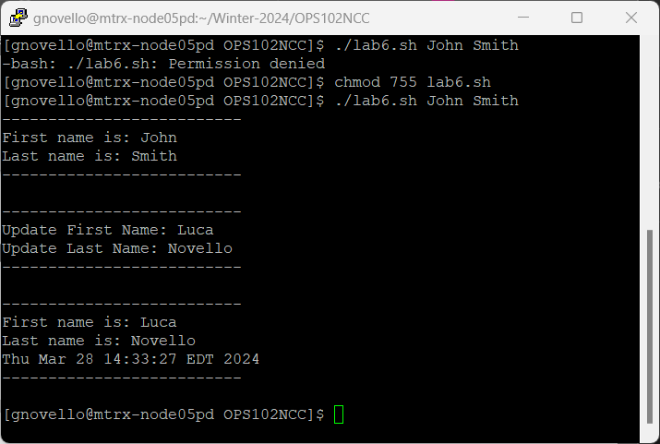

The script should look like this:

